FOOD MENU RECIPE

PORK FORELEG / HINDLEG

Type 1: PORK HIND LEG

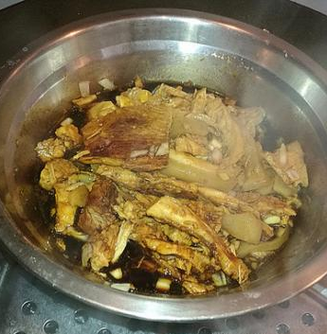

INGREDIENTS:

- 100g Pork Hind Leg
- 2 tablets Birthplace
- 2 pcs Garlic
- 1/2 root Green Onions
- Some Dried Chili
- Some Soy Sauce
- a little bit Shallots

METHOD :
- The pork hind leg is cleaned, cut into two large pieces, and the middle is cut apart, which is convenient and easy to cook.
- Bring water to a boil in a pot, add the pork hind leg to boil the froth and remove it.
- Add half a pot of water to the casserole, add dried red pepper, garlic, ginger, star anise, bay leaves, and green onions to a boil.
- Add the pork hind leg and simmer on high heat for half an hour, then simmer on low heat until the pork can be pierced with chopsticks. (Don’t simmer for too long, because the meat is too rotten to slice.)
- Slice the stewed pork and put it in a stainless steel bowl.
- Add light soy sauce, dark soy sauce, salt, and green onions to steam and serve. It's so delicious, so gluttonous!

FOOD MENU RECIPE

PORK FORELEG / HINDLEG

Type 2: SWEET AND SOUR PORK

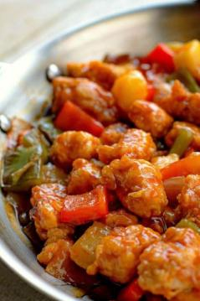

INGREDIENTS:
Marinade
- 2 Tablespoons water
- 1 Tablespoon soy sauce
- 1/2 Tablespoon sesame oil

Sauce

- 1/2 cup ketsup
- 1 Teaspoon ground ginger
- 1/2 cups white vinegar
- 1/2 cup pineapple juice
- 1 Teaspoon kosher salt
- Main dish ingredients
- 1 pound boneless pork cut into bite size pieces
- 10 ounce can pineapple chunks in juice, drained but reserving 1/2 cup juice for the sauce
- 1 large red bell pepper, cut into 1 inch pieces
- 1 large green pepper,cut into 1 inch pieces
- 1 medium onion, cut into 1 inch pieces
- 1/2 cup cornstarch
- 1 cup flour
- 1 large egg
- 1/4 cup whole milk
- 1 Tablespoon corn starch
- 1 Tablespoon water
- 1/2 cup oil, for frying the pork chunks
- 1 Tablespoon oil, to saute peppers and onions

METHOD :

For The Marinade:
- Place all the marinade ingredients in a large bowl whisk together until well incorporated. Add the pork pieces to the bowl and marinade for 30 minutes.

For The Sauce:
- Place all the sauce ingredients in a medium saucepan. Whisk together and simmer for 20 - 30 minutes on medium to low heat, set aside.
- You'll need three shallow bowls. Place 1/2 cup flour in the first bowl. Place the egg and milk in the second bowl and whisk until well incorporated. Place 1/2 cup of flour and 1/2 cup of cornstarch in the third bowl, whisk to combine.
- Dredge the pork chunks in the first bowl of flour remove them and place them in the egg/milk mixture, make sure they are coated well. Remove the pork chunks from the second bowl and dredge them in the third bowl of flour/cornstarch mixture. Set aside on a plate.
- Place a 1/2 cup of oil in a fry pan over medium heat. Fry the pork chunks in small batches for about 4 minutes on each side until crispy.
- Place one Tablespoon oil in a saute pan, add the peppers and onions to the pan. Saute for 4 - 5 minutes, add the pineapple chunks and the sauce. Mix the cornstarch and water together to form a slurry to thicken the sauce. Add the slurry to the pan and stir until thickened. Add the pork chunks and stir to coat. Serve over rice if desired.
- The first step in the recipe is to cut up a one pound piece of boneless pork into bite size pieces. Second, your going to make a very simple marinade of water, soy sauce and sesame oil to marinade the pork in for about 30 minutes.
- While your waiting for the pork to marinate, make the sauce. Place all the sauce ingredients in a bowl, whisk to combine and cook,then simmer in a saucepan for 30 minutes.
- Cutting up the peppers and onions into bite size pieces can be done ahead to save you a little prep time the night you make this.
- After the pork has marinated for 30 minutes it’s time to bread it for frying. You’ll need three shallow bowls for this step. One for the flour, one for the egg/milk mixture and the last bowl for a combination of flour and cornstarch.
- You can almost guess how this is going to go. First dredge the pork pieces in the first bowl of just flour, move them to the second bowl of egg/milk mixture and coat them until they are completely covered , then dredge the pork in the last bowl of flour/cornstarch mixture and place on a plate.
- Heat the oil in a fry pan and fry the pork bites in batches, 4 minutes on each side until crispy. Drain on a paper towel lined plate and move on to sauteing the peppers and onions and adding the pineapple and the sauce you made to the pan. A simple slurry made with cornstarch and water is mixed and added to the pan to thicken the sauce. The last step is to add the pork to the pan and fold it into that gorgeous sauce to coat it. I made long grain rice to serve it with.

