FOOD MENU RECIPE

PORK SHOULDER

Type 1: Fall-Apart Roasted Pork Shoulder with Rosemary, Mustard, and Garlic
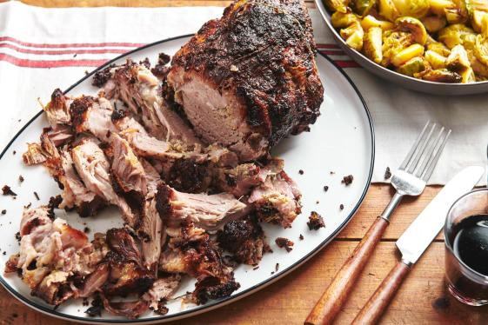

INGREDIENTS:
- 2 tablespoons chopped garlic
- 3 anchovies (rinsed)
- 2 tablespoons chopped fresh rosemary
- 2 teaspoons kosher salt
- 1 teaspoon freshly ground black pepper
- ¼ cup olive oil
- 2 tablespoons coarse Dijon mustard
- 1 (6-pound) boneless pork shoulder (trimmed of excess fat and tied)

METHOD :
- In a small food processor, combine the garlic, anchovies, rosemary, salt, and pepper. Add the olive oil and process until it forms a paste, scraping down the sides. Remove the blade and use a fork or spoon to stir in the mustard. Rub the paste all over the pork shoulder, loosely cover it with plastic wrap, and refrigerate from 2 to 24 hours.
- Preheat the oven to 450 F and bring the pork to room temperature while the oven heats. Place the pork in a shallow roasting pan and roast, uncovered, for 30 minutes, until the top starts to brown a bit.Turn the heat down to 250 F and continue to cook, uncovered, for 6 to 8 hours until the middle of the roast registers 180 F on an internal thermometer, and as you slide the thermometer in you can feel that the meat is very tender throughout. If juices are in the pan (and I have found that sometimes there are and sometimes none), pour off the juices from the pan into a heatproof container, like a Pyrex measuring cup. Place this in the fridge, where the fat will rise to the top, while the meat rests.
- When the meat is cooked, if you think that the outside of the roast could use a bit more crust/brownness, turn the heat back up to 450 F and let it cook for another 15 to 20 minutes to give the outside a bit more of a crunchy texture.
- Remove from the oven and let sit for about 20 minutes. Spoon the fat off the reserved juices in the fridge and pour the cooking juices into a serving pitcher or bowl (warm it a bit in the microwave or in a small pot if you like). Slice the pork as thinly or thickly as you like, knowing the meat will fall apart at least slightly. Sprinkle the sliced meat with a bit of salt before serving, and pass the pan juices on the side to drizzle over.
FOOD MENU RECIPE

PORK SHOULDER

Type 2: ULTRA-CRISPY SLOW-ROASTED PORK SHOULDER RECIPE

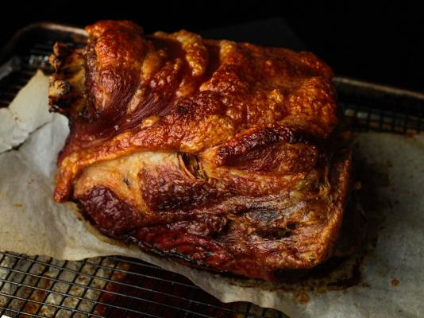

INGREDIENTS:
- 1 whole bone-in, skin-on pork shoulder, 8 to 12 pounds total
- Kosher salt and freshly ground black pepper

METHOD :
- Adjust oven rack to middle position and preheat oven to 250°F (121°C).
- Line a rimmed baking sheet with heavy duty aluminum foil (see notes) and set a wire rack inside it. Place a piece of parchment paper on top of the wire rack. Season pork on all sides liberally with salt and pepper and place on parchment paper. Transfer to oven and roast until knife or fork inserted into side shows very little resistance when twisted, about 8 hours total.
- Remove pork from oven and tent with foil. Let rest at room temperature for at least 15 minutes and up to 2 hours. Increase oven to 500°F (260°C) and allow to preheat. Return pork to the oven and roast until skin is blistered and puffed, rotating every 5 minutes, about 20 minutes total. Remove from oven, tent with foil and allow to rest an additional 15 minutes. Serve by picking in the kitchen or just bring it to the table and let guests pick meat and crispy skin themselves, dipping into sauce of their choice on the side (see notes).
- NOTES - To make a pan sauce, skip the aluminum foil when roasting; when the pork's finished, drain off and discard the excess fat and deglaze the rimmed baking sheet by heating it over a single burner and adding two cups of white wine, chicken stock, or a combination of both. Scrape up browned bits, transfer to a small saucepan, season to taste, and whisk in two tablespoons butter off heat.

