FOOD MENU RECIPE

ABALONE SLICES

TYPE 1: BRAISED ABALONE WITH SEA CUCUMBER

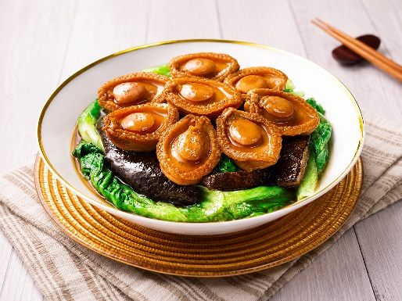

INGREDIENTS:
- 2 dried South African Deep Sea Cucumber
- 1 knob ginger, pounded
- 3 stalks scallion, roots removed
- 8 dried Japanese scallop, rinsed with water before using
- 4 oz (125g) broccoli florets
- Cornstarch + water
- Supreme Chicken Stock:
- 1 stewing hen, skin removed and chop into big pieces
- 1 lb (500g) pork spare ribs, cut into riblets
- 4 oz (125g) Chinese ham (or Virginia ham), cut into pieces
- 5 quarts water

METHOD :
- Soak the dried abalone in cold water for 24 hours. The next day, clean it thoroughly and cook in boiling water for 15 minutes. Turn off the heat, cover the pot, and let it sit until the water cools. Clean the abalone again, remove the tail end, discard any impurities, and soak in clean cold water for another 10 hours or overnight.
- Meanwhile, soak the sea cucumbers overnight in a clean, oil-free pot. The next day, bring a large pot of water to a boil. Turn off the heat and add the sea cucumbers. Cover the pot and let them sit until the water cools. Repeat this process 3-4 times until the sea cucumbers are relatively soft. At this point, clean each sea cucumber as shown in the pictures.
- Bring a pot of water to a boil, preferably in a stainless steel pot. Add the ginger, scallions, and sea cucumbers, and cook on low heat until the sea cucumbers are soft enough for further preparation.
- While preparing the dried ingredients, make the Supreme Chicken Stock. Bring water to a boil in a deep stock pot. Add the chicken, ribs, and ham, and return to a boil. Lower the heat and simmer for 8 hours, until the meat falls off the bones and the stock is very flavorful. Discard the solids and save the stock. You can keep it in the fridge.
- When you're ready to cook, use a smaller stock pot and add 3-4 cups of Supreme Chicken Stock, along with the abalone, sea cucumbers, and scallops. Bring to a boil, then reduce to low heat and simmer for 10 to 12 hours, until the abalone is tender and absorbs the flavors of the stock.
- To check for doneness, use a chopstick to poke the ingredients. Since sea cucumbers cook faster than abalone, check their texture often. Once the sea cucumbers are soft and jiggly, remove them from the pot and set aside. Add them back and reheat just before serving. Do not overcook the sea cucumbers, as they will turn into a gel-like texture.
- To serve, quickly blanch the broccoli florets in boiling water. Drain and set aside. Use some of the soup base and thicken it with a bit of cornstarch mixed with water. Arrange the abalone, sea cucumbers, and broccoli on a serving plate, then drizzle the thickened sauce on top. Serve immediately.

FOOD MENU RECIPE

ABALONE SLICES

TYPE 2: BRAISED ABALONE WITH BOK CHOY (WITH PRESSURE COOKER)

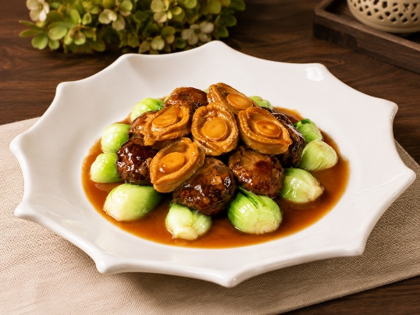

INGREDIENTS:
- 400 gr abalone fresh, frozen, or canned abalone
- 500 gr bok choy baby or regular size
- 50 gr shiitake mushrooms
- 1 tsp cooking oil
- 2 cloves garlic minced
- 1 inch fresh ginger thinly sliced
- 1 Tbsp shao xing wine

Seasonings:
- 200 ml liquid from soaking mushrooms
- 200 ml chicken broth and juice from canned abalone (if using)
- 1 Tbsp soy sauce
- 1 Tbsp oyster sauce
- 1 tsp sesame oil
- ¼ tsp sugar
- ¼ tsp salt or more to taste

To thicken sauce:
- 1 Tbsp cornstarch + 1 Tbsp water you can use potato starch too

Garnish:
- 1 stalk green onion thinly sliced
- 1 Tbsp goji berries soak in warm water until soften

METHOD :

- Soak shiitake mushrooms in 200 ml warm water for 30 minutes or until they are soft and plump. Squeeze excess water from the mushrooms. Keep the soaking liquid and trim off the stems from the mushrooms.

Blanch bok choy:
- Separate the bok choy stalks and wash clean with water. Bring a large pot of water to a boil. Add bok choy and boil for 1 minute and refresh with cold water to stop the cooking process. Set aside.

Clean the abalones (if frozen):
- Thaw the abalones if frozen. If you are using canned abalone, you can skip this part. The frozen abalones we got were shelled and already have their guts removed. However, they are still dirty. Use a little brush to brush off all the black stuff off the abalones. Rinse clean with water.
- Bring a medium pot of water to a boil. Boil the abalone for 5 minutes and then discard the water and rinse clean. The abalones are ready to be used at this point.

Pressure cook the abalones:
- Press "saute" on instant pot. Add cooking oil to inner pot. Saute garlic for 30 seconds. Add ginger slices and cook for another minute. Deglaze with a wine and scrape the bottom of the pot. Add the liquid from soaking mushrooms, chicken broth, liquid from canned abalone, and seasonings. Arrange the abalone and mushroom pieces inside. Close the lid. Turn the steam release valve to seal. Press "pressure cooker" and then "high pressure". Pressure cook on high for 50 minutes.
- After 50 minutes, wait for 5 minutes and then release pressure completely. Remove mushrooms and abalones from the pressure cooker.
- Press "saute" on instant pot and bring the braising liquid from cooking the abalones earlier to a boil. Have a taste and add more salt and/or sugar as needed. It should be savory. Give the cornstarch solution a stir and pour in and keep stirring until the sauce thickens and proceed to assembling.

If cooking on the stove:
- Preheat a large pot. Add cooking oil and saute garlic for about 30 seconds. Add ginger slices and saute for another 1 minute. Deglaze with wine. Scrape the bottom of the pot. Add the liquid from soaking mushrooms, chicken broth, liquid from canned abalone, and seasonings. Bring to a boil then add mushrooms, and abalone pieces. Lower the heat and cover with a lid and let it simmer for the next 2-2 1/2 hours or until the abalone pieces are tender.

If using canned abalone (which is usually already cooked):
- You can skip the pressure cooking part and just prepare the sauce. Preheat a large pot. Add cooking oil and saute garlic for about 30 seconds. Add ginger slices and saute for another 1 minute. Deglaze with wine. Scrape the bottom of the pot. Add the liquid from soaking mushrooms, chicken broth, liquid from canned abalone, and seasonings. Bring to a boil, add mushrooms and let it simmer for about 30 minutes.
- Put the canned abalone pieces in the there and let them simmer over medium heat for about 2 minutes or so. Don't over cook them as they will turn rubbery. Give the cornstarch solution a stir and pour as you stir until the sauce is thickened. Proceed to assemble the dish.

Assembling:
- When abalones and mushrooms are cool enough to handle, slice them into about 1/4-inch thickness. Arrange the bok choy on the platter decoratively (if you like). Arrange the slices of abalone next and then the mushrooms.
- Drizzle the sauce generously over the dish, garnish with chopped green onion and serve. In the video, I use goji berries for the pop of red color.

