FOOD MENU RECIPE

BRACKISH WATER FISH SLICE

Type 1: SPRING ONION GINGER FISH FILLETS (姜葱鱼片)

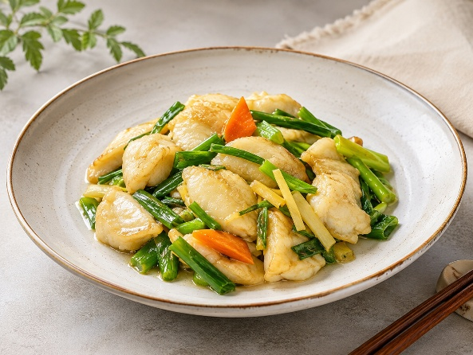

INGREDIENTS:

- 400g fish fillets
- 1 tbsp garlic, minced
- 15 slices of ginger, soaked in 1 tbsp of shaoxing wine
- 2 bunches of spring onion, cut into sections
- some cooking oil
- For the Fish Marinade:
- 2 tbsp shaoxing wine
- 1 tbsp sugar
- 1 tsp salt
- 1 egg white
- 4 tsp corn flour
- ½ tsp pepper
- For the Seasoning:
- 1½ tbsp oyster sauce
- ¾ tbsp light soya sauce
- 2 tsp sugar
- ½ tsp chicken powder
- dash of pepper
- 200ml water
- Corn Flour Thickening : 2 tsp corn flour + 2 tbsp water

METHOD :
- Marinade the fish fillets with the marinade ingredients and set it aside in the fridge for at least an hour.
- Heat up some cooking oil till hot and blanch the marinated fish in the oil for approximately 1 minute.
- Drain the fish well and place them on paper towels to soak up the excess oil.
- Reserving one tbsp of cooking oil in the wok, add in the minced garlic, white parts of spring onion and the sliced ginger. Stir fried briefly till aromatic.
- Add in all the seasoning ingredients and allow it to simmer on low heat till it boils.
- Add in the corn flour thickening.
- Once the sauce starts to thicken, add in the fish slices. Stir to mix well.
- Add the green parts of the spring onion and the shaoxing wine that's used to soak the ginger. Stir briefly to mix and off the flame.
- Serve hot immediately with rice or congee.

FOOD MENU RECIPE

BRACKISH WATER FISH SLICE

Type 2: EASY FRIED FISH FILLETS

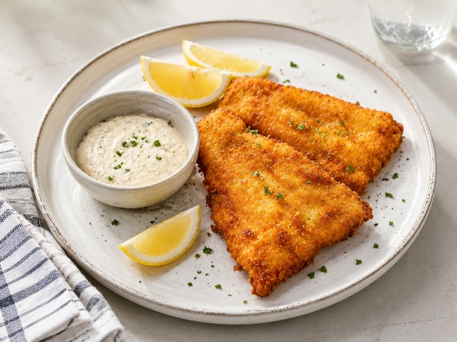

INGREDIENTS:
- 1/2 cup all-purpose flour
- 1/2 teaspoon fine salt, or to taste
- 1/4 teaspoon freshly ground black pepper, or to taste
- 1/4 teaspoon paprika
- 1 pound fish fillets, such as haddock, tilapia, or cod
- Vegetable oil, for frying
- Lemon wedges, tartar sauce, or rémoulade, optional

METHOD :
- Gather the ingredients.
- In a shallow bowl or deep plate, combine the flour, salt, pepper, and paprika. Mix well.
- Dip 1 or 2 fish fillets into the flour mixture. Make sure they are completely coated on all sides. Gently shake off any excess. Repeat with the remaining fillets.
- Pour about 1/2-inch of oil into a large skillet and heat over medium-high heat until the oil shimmers.
- Working in batches, fry the fillets until golden brown and crisp, about 6 minutes. Turn with tongs and continue cooking until golden brown, crisp, and cooked through, about 6 minutes more. Transfer to a cooling rack to drain.
- Serve hot with lemon wedges, tartar sauce, or homemade rémoulade sauce, if desired. Enjoy.

