FOOD MENU RECIPE

FRESHWATER PRAWN

Type 1: PAN FRIED FRESH WATER PRAWN

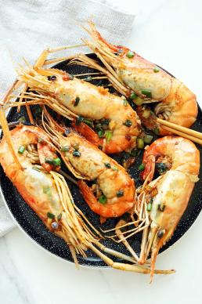

INGREDIENTS:
- 6 Fresh Water Prawn (jumbo prawn or big tiger prawn).
- 1 ½ tablespoons Oil cooking
- 2 cloves Garlic (coarsely chopped)
- 1 tablespoon Soy Sauce
- 1 tablespoon Shaoxing Wine
- ½ teaspoon Sugar
- 1 tablespoon Scallions (chopped)

METHOD :
- Using a sharp knife, make a shallow incision along the back of the prawn. Remove the dark vein, then rinse with water and pat dry with paper towels.
- Add oil to a wok or pan. Once the oil is heated, add the garlic and stir-fry until aromatic and light brown in color.
- Add in the fresh water prawns, soy sauce, wine, sugar and do a few quick stirs.
- Use the wok turner to press down on each prawn, pan-frying both sides until they are fully cooked.
- Add the chopped scallions and stir to combine with the prawns. Serve hot.

FOOD MENU RECIPE

FRESHWATER PRAWN

Type 2: GRILLED CHEESE PRAWN

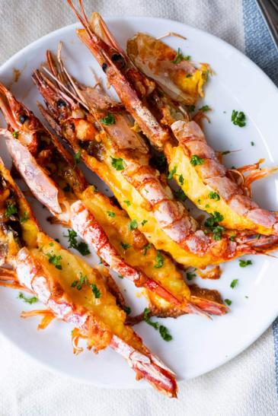

INGREDIENTS:
- Large prawns
- Mayonnaise
- Egg yolk
- Shredded cheese
- Fresh Parsley

METHOD :
- First, clean the prawn. Using a knife or scissor, make a shallow cut down the middle of the back of each prawn, don’t cut all the way through.
- Next, combine the mayonnaise and egg yolk and coat evenly on each prawn. Stuff with shredded cheese.
- Pick fresh large prawns for the best taste. Fresh prawns will have a sweet and succulent flavor, enhancing the overall taste of your grilled cheese prawns.
- Don’t Overcook the Prawns. Prawns cook quickly, and overcooking can result in a rubbery texture. Keep a close eye on them while baking, and remove them from the oven as soon as they turn pink and opaque. This will ensure they remain juicy and tender.
- Select a cheese that melts well and complements the prawns. Cheddar, mozzarella, Gouda, or a blend of cheeses are excellent choices. Avoid using cheeses that are too pungent or overpowering, as they may mask the delicate flavors of the prawns.

