FOOD MENU RECIPE

LALA CLAMS

Type 1: STIR FRIED CLAM (LALA) WITH GARLIC & GINGER

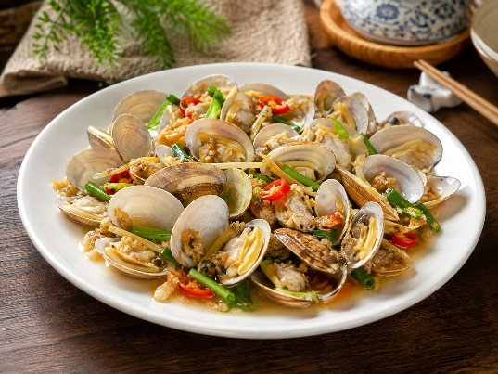

INGREDIENTS:
- 410g Clams (Lala)
- 20g Chopped Garlic
- 70g Chopped Ginger
- 1 Chopped Chili
- Note : Soak with water for 20 minutes and then wash more than four times.

METHOD :
- Heat cooking oil and add chopped Garlic.
- Stir fry for 3 minutes.
- Add chopped Ginger and chopped Chili.
- Stir fry until the garlic slightly brown.
- Add Clams (Lala) and stir fry until the shell of the clams turn orange colour.
- Please do add water. There will be water oozing out from those Clams (Lala).
- Add 2 tablespoon of Oyster Sauce and 1/2 cup of Chinese Wine.
- Stir fry until combined.
- Note : We like the taste of the Chinese Wine, thus I added 1 cup.
- Taste before dish up. Serve immeditely.

FOOD MENU RECIPE

LALA CLAMS

Type 2: KAM HEONG CLAMS

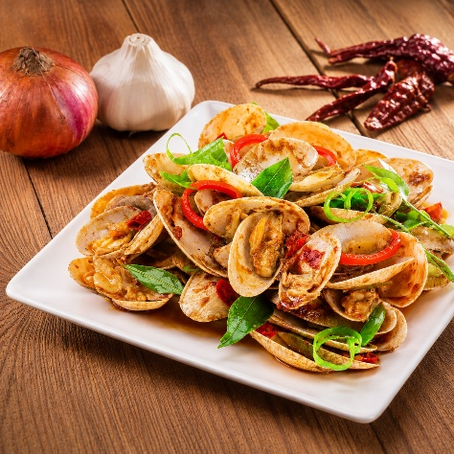

INGREDIENTS:
- Fresh clams – I used Manila clams in this recipe. You may use any hard-shelled clams you like.
- Sambal – Check out my sambal recipe. You can make the sambal in advance; keep it in the fridge and use it to prepare a variety of dishes such as sambal udang, sambal asparagus, and sambal telur.
- Dried shrimp – Adds a crunchy texture and a salty, umami flavor that complements the clams.
- Curry leaves – Gives the dish its signature fragrance with a unique, fresh flavor and a hint of citrus.
- Curry Powder (optional) – These days, most hot stir-fry stalls (choo char/tze char) in Malaysia adds curry powder to the kam heong sauce. The ingredient is optional, you may add or skip curry powder in the sauce.

METHOD :
- Clean and rinse the clams thoroughly, scrubbing their surfaces, and then set them aside.
- Heat oil in a wok. Add garlic and stir fry until aromatic (but not browned), then add the sambal, dried shrimp, chilies, curry leaves, and curry powder (if using). Continue to cook until fragrant.
- Add the clams and stir to combine them well with the other ingredients. Then add the oyster sauce, sweet soy sauce, sugar, and Shaoxing wine. Cover the wok and let the clams cook until they open.
- Remove the wok cover, give the clams a quick stir, then dish them out and serve immediately with steamed white rice.

