FOOD MENU RECIPE

PORK BELLY

Type 1: SHANGHAI-STYLE BRAISED PORK BELLY (HONG SHAO ROU)

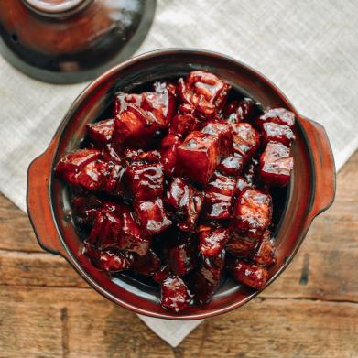

INGREDIENTS:
- 1 1/2 pounds lean, skin-on pork belly
- 2 tablespoons oil (any neutral oil, such as canola, vegetable, or avocado oil)
- 2 tablespoons rock sugar (or granulated sugar)
- 1/3 cup Shaoxing wine (or dry cooking sherry)
- 2 tablespoons soy sauce
- 1 tablespoon dark soy sauce (see dark soy sauce substitute if needed; real dark soy sauce is important for color)
- 2-3 cups water

METHOD :
- Cut your pork belly into 3/4-inch thick pieces. Add them to a medium pot and cover with water. Bring the water to a boil, and boil for about 1 minute, or just until the pork turns opaque. This removes impurities and starts the cooking process. Take the pork out of the pot, rinse, and set it aside. Discard the water and clean out your pot.
- Over low heat, add the oil and sugar to your wok or pot. Melt the sugar, and add the pork. Raise the heat to medium, and cook until the pork is lightly browned.
- Reduce the heat to low, and add the wine. Cook for 2 minutes, then add the soy sauce, dark soy sauce, and water.
- Cover and simmer over medium heat for about 45 minutes to 1 hour, until pork is fork tender. Every 5-10 minutes, stir to prevent burning and add more water if it gets too dry.
- Once the pork is fork tender, if there is still a lot of visible liquid, uncover the wok, turn up the heat, and stir continuously until the sauce has reduced to a glistening coating.
- Tips & Notes:
The water should mostly cover the pork belly in the pot in order to braise it properly. If using a thick-bottomed pot, you may need less—say 2 cups, as it will evaporate slower. That said, you can also just cook it longer to reduce the sauce.

FOOD MENU RECIPE

PORK BELLY

Type 2: HONEY GLAZED FRIED PORK BELLY WITH CARROTS

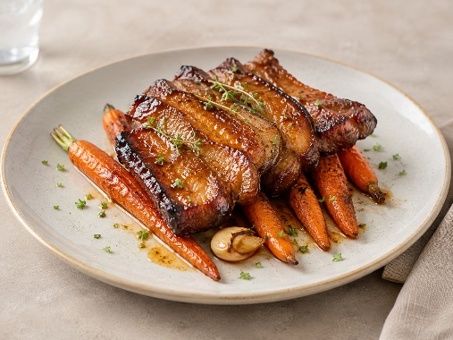

INGREDIENTS:
- 1200 g pork belly
- 2 g salt
- 2 g pepper
- 1 tsp honey
- 1 tsp soy sauce
- 80 g carrots
- 60 g butter
- 1 sprig of thyme
- 2 garlic cloves

METHOD :
- Season the pork belly on both sides with salt and pepper, wrap in baking paper and aluminum foil, and bake in a tray with a little water for about 1 h 45 at 165 °C (330 °F).
- This will ensure the meat will be moist and tender.
- Once cooked, place in the refrigerator for a while to make it easier to slice.
- In a frying pan, melt the butter with the garlic and thyme. Add the carrots and cook over medium heat for about 8-10 minutes until they start to brown but are still a bit crunchy.
- Before serving, slice the pork belly into pieces about 1 cm ( about 1/2 inch) thick and fry on both sides in a hot pan. When they are almost done, take the pan off the heat and add the honey and soy sauce mixture to the pan, glaze the pork pieces and place on a plate before the honey burns.

FOOD MENU RECIPE

PORK BELLY

Type 3: PORK BELLY CRACKLINGS

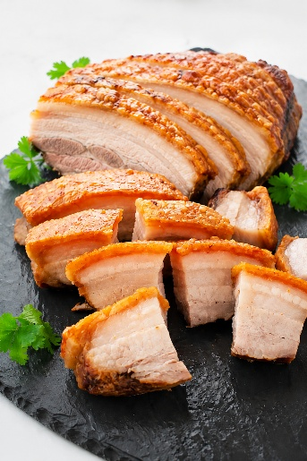

INGREDIENTS:

Pork Belly
- 1 ½ lb boneless pork belly
- 2 tablespoons brown miso
- 2 tablespoons maple syrup
- 1 teaspoon Chinese five spice
- 1 teaspoon sesame oil
- 1 teaspoon flaky sea salt (Maldon salt works great)

Chipotle Aioli
- ¼ cup mayonnaise
- 1 teaspoon lime juice (fresh squeezed)
- 1 teaspoon maple syrup
- ½ teaspoon pureed chipotle peppers in adobo sauce
- 4 drops liquid smoke
- 1 small garlic clove (very finely minced)
- ½ teaspoon dijon mustard
- ⅛ teaspoon sea salt

METHOD :
- Preheat the oven to 275 degrees. Line a baking tray with parchment paper and place an ovenproof wire rack on top of it.
- Dry the pork belly with paper towels. Make cuts in the pork belly skin 1 inch apart. When you finish one direction, make cuts in the other direction so that the top of the pork belly has been cut into little squares. This helps the fat render and makes it much easier to cut and eat once it's cooked. Make sure you cut all the way through the skin (into a little of the fat is ok) but do not cut through to the meat. Turn the pork belly over and stab the meat all over with the tip of your knife. *1 ½ lb boneless pork belly
- In a small bowl mix together the miso, maple syrup, and Chinese five spice. Liberally coat the meat (not the skin!) side of the pork belly. Place the pork belly skin side up on top of the wire rack.*2 tablespoons brown miso, 2 tablespoons maple syrup, 1 teaspoon Chinese five spice
- Pour the sesame oil over the top of the skin and massage it in. Sprinkle the top liberally with the flaky sea salt. *1 teaspoon sesame oil, 1 teaspoon flaky sea salt
- Bake the pork belly for 2 hours in the center of your oven. Increase the oven temperature to a low broil – see notes! Move the pork belly to a rack in the top third of your oven. Broil it for 10-15 minutes, or until the pork skin is very crispy.
- While the pork is in the oven, make the chipotle aioli. Whisk the ingredients in a small bowl. Cover and place it in the fridge until you are ready to serve it. *¼ cup mayonnaise, 1 teaspoon lime juice, 1 teaspoon maple syrup, ½ teaspoon pureed chipotle peppers in adobo sauce, 4 drops liquid smoke, 1 small garlic clove, ⅛ teaspoon sea salt, ½ teaspoon dijon mustard
- Remove the pork belly from the oven and let it sit for 15 minutes, uncovered. Slice the pork belly and serve with the chipotle aioli on the side.

