FOOD MENU RECIPE

PORK FORELEG / HINDLEG

Type 1: PORK HIND LEG

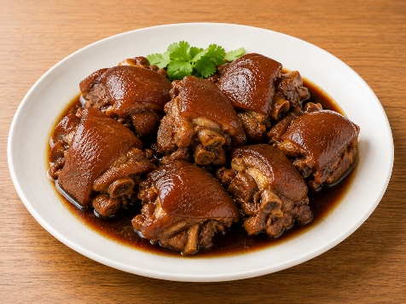

INGREDIENTS:

- 100g Pork Hind Leg
- 2 tablets Birthplace
- 2 pcs Garlic
- 1/2 root Green Onions
- Some Dried Chili
- Some Soy Sauce
- a little bit Shallots

METHOD :
- The pork hind leg is cleaned, cut into two large pieces, and the middle is cut apart, which is convenient and easy to cook.
- Bring water to a boil in a pot, add the pork hind leg to boil the froth and remove it.
- Add half a pot of water to the casserole, add dried red pepper, garlic, ginger, star anise, bay leaves, and green onions to a boil.
- Add the pork hind leg and simmer on high heat for half an hour, then simmer on low heat until the pork can be pierced with chopsticks. (Don’t simmer for too long, because the meat is too rotten to slice.)
- Slice the stewed pork and put it in a stainless steel bowl.
- Add light soy sauce, dark soy sauce, salt, and green onions to steam and serve. It's so delicious, so gluttonous!

METHOD :

