FOOD MENU RECIPE

PORK MINCED MEAT

Type 1: GINGER MINCED PORK RICE BOWL



INGREDIENTS:
- 1 pound ground pork
- 1 tablespoon grated ginger
- 1 tablespoon oil
- 1 tablespoon sugar
- 1 tablespoon rice cooking wine
- 3 tablespoons soy sauce
- 1 tablespoon sesame oil
- 4 stalks scallion, chopped
- 1 tablespoon roasted sesame seeds
- 4 cups cooked white or brown rice

METHOD :
- Whisk together sugar, rice cooking wine and soy sauce in a small container.
- Heat oil in a large skillet over medium-high heat, add ground pork and grated ginger, cook 2-3 minutes or until pork has turned brown (make sure to crumble the meat as it cooks).
- Stir in the seasoning mixture, mix until well combined, allow it to simmer for 2 minutes.
- Toss in sesame oil, roasted sesame seeds and chopped scallion, cook another 30 seconds before removing from heat.
- Place rice in a bowl, spoon some ginger minced pork on top to serve and enjoy!
- NOTES : 1 cup uncooked brown rice usually yields 4 cups cooked brown rice, 1 cup uncooked white rice usually yields 3 cups cooked white rice only.

FOOD MENU RECIPE

PORK MINCED MEAT

Type 2: HEALTHY STEAMED TOFU WITH GROUND MEAT

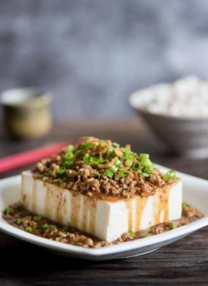

INGREDIENTS:
- 1 pack soft tofu (12 oz)
- ¼ pound ground pork
- For marinating the meat:
- 1 tablespoon soy sauce
- 1 tablespoon sesame oil
- 1 tablespoon cooking wine
- 1 tablespoon oyster sauce
- half teaspoon potato starch
- half teaspoon ginger powder
- Garnish:
- 1 stalk green onion, chopped
- Sauce and topping (optional):
- soy sauce to taste
- chili garlic sauce to taste

METHOD :
- Marinate the ground pork with the mixture of soy sauce, sesame oil, cooking wine, oyster sauce, potato starch and ginger powder for 10 minutes.
- Carefully remove the tofu from the package and place it in a shallow bowl.
- Slice the tofu width-wise into half-inch thick slices.
- Spread the marinated ground pork onto the tofu and transfer the shallow bowl into a steamer.
- Bring the water to a boil over high heat.
- When the steam starting to emerge, carefully transfer the steamer into the pot, cover and reduce the heat to medium.
- Steam the tofu for 10-15 minutes or until fully cooked.
- Carefully remove the cover of the steamer (watch out for the steam) and sprinkle freshly chopped green onion on top to serve.
- Enjoy while hot.

