FOOD MENU RECIPE

PORK RIBS

Type 1: NYONYA STEWED PORK RIBS

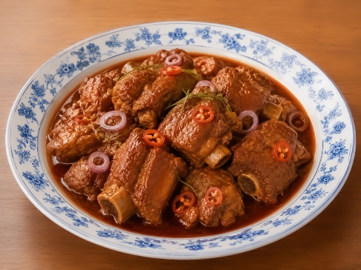

INGREDIENTS:
- 450 g (16 oz) pork spare ribs
- 100 g (3½ oz) shallots, skin peeled
- 100 g (3½ oz) fresh red chilies, seeded and sliced lengthwise
- 4 cups water
- 3 tablespoons taucheo, bean paste, smashed with a mortar and pestle
- 1 tablespoon tamarind pulp, soaked in 1/4 cup water, extract the juice
- 1 1/2 teaspoons sugar , or to taste
- salt to taste

METHOD :
- Grab a stew pot, add about 4 cups of water, and bring it to a boil. Super easy!
- Once the water’s boiling, toss in the shallots, chilies, and pork ribs.
- Next, stir in the taucheo (bean paste) and bring everything back to a boil. Let those flavors come together.
- Turn the heat down to medium or low, cover it up with a lid, and let the ribs stew gently for about an hour, or until they’re nice and tender.
- Now, toss in the tamarind juice, a little sugar, and salt to taste. Give it a good stir and adjust the flavors to your liking.
- If it’s not sour enough for your taste, just mix a bit more water into the tamarind pulp and squeeze out some extra juice. That should do the trick!

FOOD MENU RECIPE

PORK RIBS

Type 2: OVEN-BAKED BBQ PORK RIBS
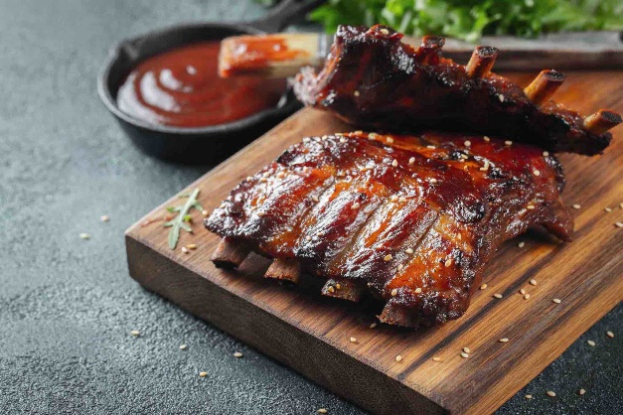

INGREDIENTS:
- 2 racks of baby back ribs or spare ribs
- 1 tablespoon smoked paprika
- 1 teaspoon salt
- 1 teaspoon black pepper
- 1 teaspoon onion powder
- 1 teaspoon garlic powder
- 1 cup BBQ sauce

METHOD :

- Preheat your oven to 275°F (135°C).
- Remove the membrane from the ribs and apply the spice rub evenly over both sides.
- Place ribs on a baking sheet covered with foil and bake for 3.5 to 4 hours.
- Brush with BBQ sauce and broil for 3-5 minutes until caramelized.

