FOOD MENU RECIPE

PORK SLICED MEAT

Type 1: SLICED PORK WITH GARLIC SAUCE (SUAN NI BAI ROU)

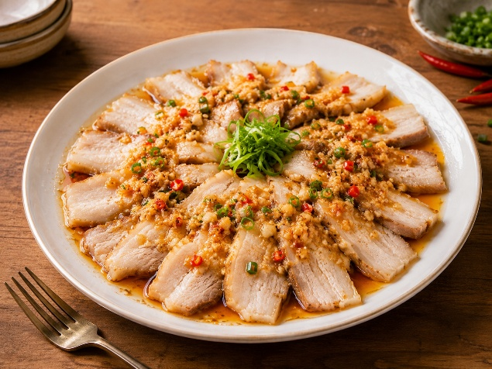

INGREDIENTS:

To boil the pork belly:
- 1 pound lean pork belly(preferably one whole piece)
- 6 cups cold water
- 5 slices ginger
- 1 star anise
- 2 tablespoons Shaoxing wine
- 2 scallions
- 1 teaspoon Sichuan peppercorns

To make the sauce:

- 10 cloves garlic(minced)
- 3 slices ginger (minced)
- 1 scallion (finely chopped with the white and green parts separated)
- 2 tablespoons red chili flakes (or to taste)
- 1 teaspoon Sichuan peppercorn powder
- ⅓ cup oil (heated to 225 degrees F)
- 3½ tablespoons light soy sauce
- 1 tablespoon Chinese black vinegar
- 1 tablespoon sugar
- 1 teaspoon sesame oil
- 1 tablespoon sesame paste/tahini (optional)
- 1 small cucumber (julienned)
- ⅓ cup water from boiling the pork belly
- 1 tablespoon toasted sesame seeds

METHOD :

- In a medium-sized pot, add 1 pound lean pork belly, 6 cups cold water, 5 slices ginger, 1 star anise pod, 2 tablespoons Shaoxing wine, 2 whole scallions and 1 teaspoon whole Sichuan peppercorns. Bring it to a boil, then reduce to a simmer for 30-40 minutes until the meat is fork tender. Transfer the pork belly to a plate to cool, reserving ⅓ cup of the water you used to poach the pork. Remember to cover the pork belly with an overturned plate or bowl to prevent it from drying out.
- While the pork belly is cooling, make the sauce in a heatproof bowl by adding 10 cloves of minced garlic, 3 slices of minced ginger, the white part of 1 scallion, finely chopped, 2 tablespoons red chili flakes, and 1 teaspoon Sichuan peppercorn powder.
- Now heat ⅓ cup oil to 225 degrees F, and pour it over the spices (especially the red chili flakes so you get that nice red color). Mix well before adding 3½ tablespoons light soy sauce, 1 tablespoon black vinegar, 1 tablespoon sugar, 1 teaspoon sesame oil, and 1 tablespoon sesame paste (optional). Stir until well-combined. Set aside.
- Julienne the cucumber, and arrange at the bottom of your serving plate. Once the pork belly is cool enough to handle, thinly slice it and arrange the slices neatly on the plate. Before serving, add the ⅓ cup of pork stock (from boiling the pork belly) to the sauce (warm or at room temperature is fine), and stir in 1 tablespoon toasted sesame seeds. Pour the finished sauce evenly over the pork, sprinkle with the green parts of the scallion, and serve.

FOOD MENU RECIPE

PORK SLICED MEAT

Type 2: GREEN PEPPER AND SLICED PORK

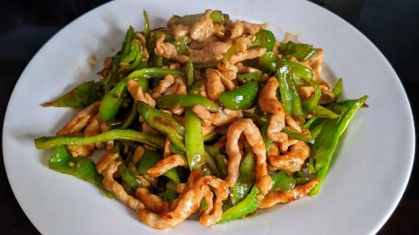

INGREDIENTS:
- half pound thinly sliced pork for hot pot (or shabu-shabu, Japanese hot pot)
- 2 Korean green peppers, sliced
- 2 cloves garlic, sliced
- 1 tablespoon oil
- ¼ teaspoon salt
- ¼ teaspoon sugar
- ¼ teaspoon black pepper
- 1 teaspoon dark soy sauce
- 1 teaspoon cooking wine
- 1 teaspoon oyster sauce

METHOD :
- Heat oil in a skillet over medium-high heat, sauté garlic and pepper slices for up to a minute or until fragrant.
- Add in the pork, stir fry for a few minutes until only a few pink spots left (80% cooked)
- Toss in salt, sugar, black pepper, dark soy sauce, cooking wine and oyster sauce, stir to mix the seasonings well with the ingredients.
- Continue cooking and constantly stir a few minutes until the pork has cooked through.
- Transfer to a plate and serve while hot.

