FOOD MENU RECIPE

SALMON FISH SLICE

Type 1: GARLIC BUTTER SALMON

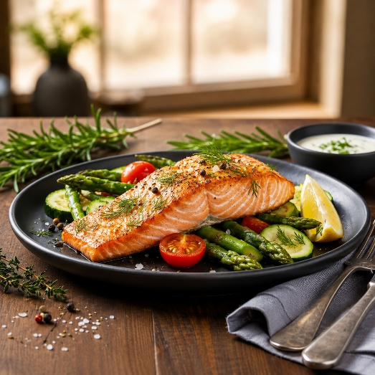

INGREDIENTS:
- 4 Salmon Fillets
- 1/2 Tsp Smoked paprika
- 1/2 Tsp Garlic Granules
- 1/2 Tsp Aromat Seasoning
- 1/2 Tsp Mixed Herbs
- 1/2 Tsp White Pepper
- 1 Tbsp Olive Oil
- 1-2 Tbsp Unsalted Butter
- 1 Tsp Minced Garlic
- 1 Tbsp Fresh Parsley

METHOD :
- Add salmon fillets to a bowl and sesaon with smoked paprika , garlic granules, aromat seasoning, mixed herbs, white pepper and olive oil.
- Mix everything together well, cover and allow salmon to marinate for 30 minutes in the refrigerator.
- Add a little bit of olive oil to a pan and sear the salmon for 5-10 minutes on both sides. Remove the salmon once seared and set aside.
- Discard the remaining olive oil, add unsalted butter and allow it to melt. Add minced garlic and saute until fragrant. Add fresh parsley, lemon juice and simmer for 2 minutes. Add the seared salmon and allow garlic butter so penetrate the salmon.
- Serve and enjoy with a side dish of choice.

FOOD MENU RECIPE

SALMON FISH SLICE

Type 2: HONEY SESAME SALMON

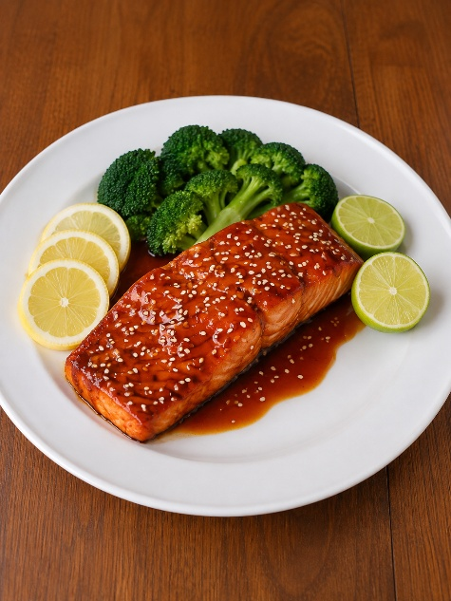

INGREDIENTS:
- 2 Fillet of salmon, cut into cubes
- 1 Tbsp sesame oil
- 1 Tbsp honey
- 1 Tbsp soy sauce
- 1 Tsp paprika
- Steamed rice for serving
- Green onions for garnish
- A mix of sriracha and Kewpie mayo for topping sauce

METHOD :
- Cut your salmon and put it in a bowl. Add the sesame oil, soy sauce, paprika and honey and mix well until salmon is evenly coated.
- Steam your rice so it’s ready as the salmon cooks very quickly.
- Heat up a nonstick skillet or cast iron to medium high heat. Add some olive oil and then add your salmon chucks. Cook for about 3 minutes per side until nicely browned and cooked through , then garnish with green onions and serve with rice and veggies if your choice (used cucumber, avocado, edamame).
- Mix a little bit of sriracha with some kewpie mayo and drizzle it over the top if desired. Enjoy!

