FOOD MENU RECIPE

SCALLOP

Type 1: EASY GARLIC LEMON SCALLOP

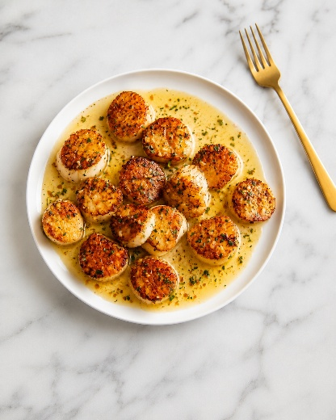

INGREDIENTS:
- ¾ cup butter
- 3 tablespoons minced garlic
- 2 pounds large sea scallops
- 2 tablespoons fresh lemon juice
- 1 teaspoon salt
- ⅛ teaspoon pepper

METHOD :
- Gather all ingredients.
- Melt butter in a large skillet over medium heat. Stir in garlic and cook for a few seconds until fragrant.
- Arrange scallops in a single layer in the skillet; cook until golden brown on one side, about 2 minutes. Turn scallops over using tongs and continue cooking until firm and opaque, about 2 minutes more.
- Transfer scallops to a platter, reserving butter in the skillet.
- Whisk lemon juice, salt, and pepper into butter; pour sauce over scallops to serve.
- Enjoy.

FOOD MENU RECIPE

SCALLOP

Type 2: CREAMY GARLIC SCALLOPS

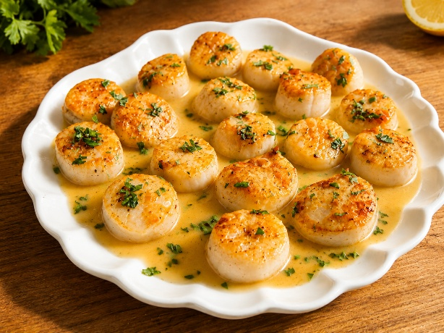

INGREDIENTS:
- 400 g (14 oz) extra large king scallops this is about 10-12 large scallops (see notes if buying frozen)
- ¼ tsp salt
- ¼ tsp black pepper
- 1 ½ tbsp avocado oil
- 1 tbsp butter
- 2 cloves minced garlic
- ¼ tsp chilli flakes (red pepper flakes)
- 80 ml (1/3 cup) white wine (just enough to deglaze the pan)
- 120 ml (1/2 cup) double (heavy) cream
- 1 tbsp lemon juice
- 1 tbsp capers in brine, drained
- 4 tbsp finely chopped fresh parsley

To serve:
- lemon wedges
- black pepper

METHOD :
- Take the scallops out of the fridge about 15 minutes before you want to cook them. *400 g (14 oz) extra large king scallops
- Line a tray with two layers of kitchen roll. Place the scallops on the lined tray and pat the tops of the scallops with more kitchen roll.
- Place a fresh layer of kitchen roll on top of the scallops and press down lightly again. Leave for 10 minutes so the kitchen roll can soak up excess moisture from the scallops.
- Warm a plate up with some hot water, or place in a very low oven.
- Remove the kitchen roll from the scallops (it should peel off, almost sticking to the scallops – so you know they're nice and dry). Season the scallops on both sides with the salt and pepper. *1/4 tsp salt,1/4 tsp black pepper
- Heat the oil in a large frying pan over a high heat. *1 1/2 tbsp avocado oil
- Once the oil is shimmering hot, add the scallops to the pan, making sure there's space between each one.
- Cook for 3-4 minutes, until dark golden brown, then turn over. The scallops should pull away from the pan when they're ready to turn.
- Add the butter to the pan and cook for a further 60 – 90 seconds, spooning the butter over the scallops as it melts and bubbles. The scallops should be lightly browned on the second side and cooked through (you can check one by cutting through it – it should be opaque throughout). *1 tbsp butter
- Turn the heat down to medium and remove the scallops from the pan. Place on the warm plate.
- Add the garlic and chilli flakes to the pan and cook for 30 seconds, constantly stirring, then add the white wine.
*2 cloves minced garlic,1/4 tsp chilli flakes,80 ml (1/3 cup) white wine
- Let the wine bubble for 1-2 minutes, until reduced by half.
- Stir in the cream, lemon juice, and capers and heat through for a further minute. *120 ml (1/2 cup) double (heavy) cream,1 tbsp lemon juice,1 tbsp capers in brine, drained
- Stir the parsley into the sauce, then add the scallops back into the pan. Heat for 30 seconds or so, then turn off the heat. *4 tbsp finely chopped fresh parsley
- Serve the scallops with lemon wedges and a sprinkling of black pepper.
*lemon wedges,black pepper

